Cathedral Prep Christmas Greeting and 50 Year update.

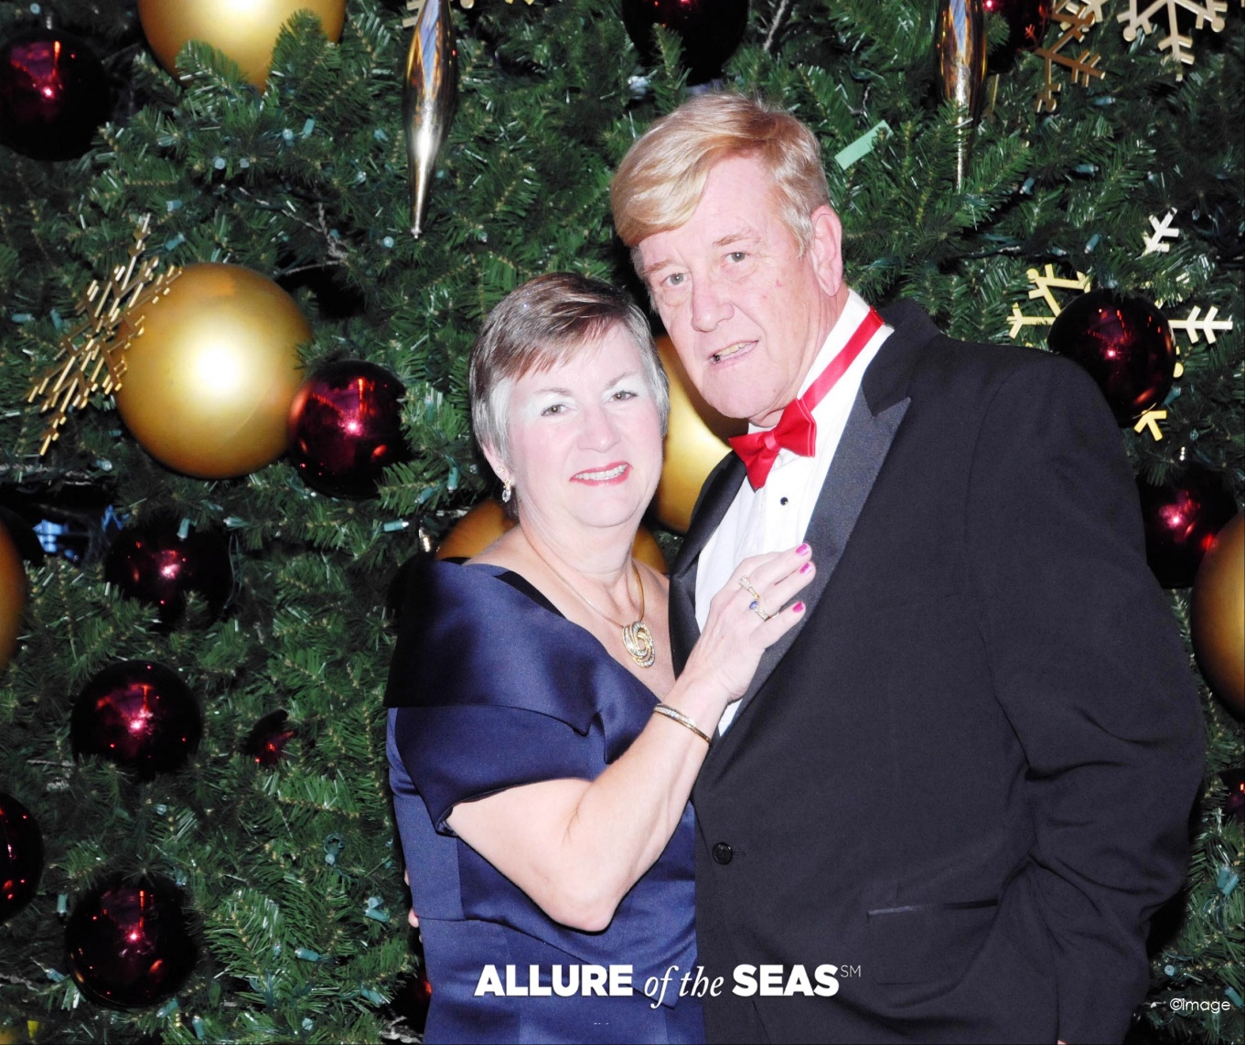

My name is Stephen Ryan, Prep Class of 69’. To begin, I would like to wish all a very Merry Christmas and Happy New Year. Now for my update… Going to the Prep in 1965 was one of the best parts of my life. It helped me get through one of the hardest times of my life and kept me focused when most needed. My father passed and was buried less than 10 days before Freshman year started. My mom was an alcoholic mother of 5 with me as oldest. I became the man in my family and the Prep got me through that challenge. Mr. Vincent Scotti was my biggest inspiration and supporter over the next 4 years. From just about day 1, he was aware of my situation and immediately became my mentor and Big Brother. Over the next 50 yrs, we stayed in touch. I’m sure he as well as Mr. Bill Poli were special for many of the Prep graduates and deserve all the recognition they get today. While at the Prep, I was a class president, chess club president, student council, basketball player, cross-country track runner (loved the reservoir and back steps, not), baseball player, Cathedralite and yearbook staff. I lived in the Bronx and got the privilege of riding the subway and bus to West End every day. Finally, I was the shortest person in class for all 4 years being only 4’ 9” at graduation; today, I stand at 5’8”. After graduation, I initially attended Manhattan College and worked in supermarkets. Unfortunately, that ended as I had to work full-time so no college. I looked everywhere for the work I wanted but no luck. Being in the middle of Vietnam war and my desire to move on with my life, I joined the Air Force in 1972 and I loved it. The first 8 years, I was enlisted, got my degree from University of Maryland, and then became an officer. I retired from the Air Force in 1994 in Tucson, Arizona as a Major. I then became a contractor working for the Government until 2014 when I retired for good. From 1989 to 2001, I lived in Tucson and then moved to Yorktown, Virginia where we currently live. During my time in the Air Force, as a contractor, and a retiree, I married my most beautiful and precious wife in 1977. We had two girls who gave us 3 grandchildren (2 boys and a girl). We travelled worldwide to include the Far East, Europe, Middle East, and South America during my time in service. When in the US we have lived in Upstate New York, Florida, and Maryland for 5 yrs, Arizona 12 years, and Virginia for 22 years. In all we visited over 60 countries and 42 states. The love of my life and I are looking forward to being married for 50 years in 2027. My wife worked as a manpower management analyst for the government for 30 years and retired in 2012. Our only regret as we get older is losing our ability to travel. We find it harder each day to move around. Therefore, coming home to New York and Maryland for events is not something we believe is in our future. This brings me to a close. Therefore, I want to once again take this opportunity to wish everyone a Merry Christmas and Happy New Year.

