XMAS GREETING 2023 JMM

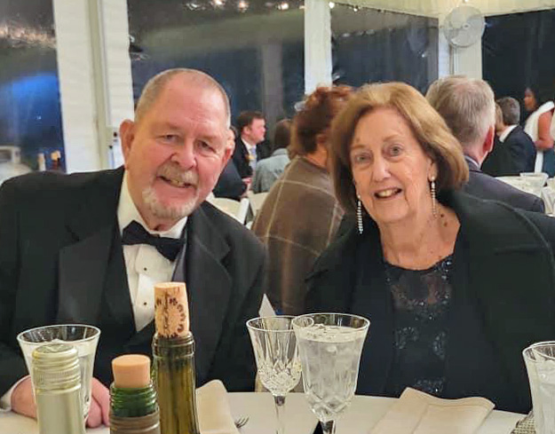

Merry Christmas to my former classmates and to other Alumni whom I have had the pleasure of meeting and collaborating with since my silent departure from the hallowed halls of 555 West End Avenue in 1960.
Early in 1959, Rev John Considine, then Dean of Studies suggested I find an alternate means of education subsequent to 4th Year.
So! In September of 1960 I found myself as a freshman in Iona College, now University, Business School. I majored in Accounting and graduated in 1964. I interned with Peat Marwick & Mitchell (Now KPMG) in late 63 and early 64 and was immediately employed upon graduation.
I worked for PMM in New York City for 3 years, was successful but my heart was not into the daily commute from Westchester to/thru/ and return from NYC.
In August of 1969, I swore the oath as a Special Agent of the FBI in Washinton DC. From Quantico, VA to Tampa Florida to Cleveland Ohio and finally back to Washington, DC, I retired 26.5 years later in 1994.
As an Accountant, my specialty was White Collar Crime. However, I also worked Organized Crime and Other Crime Programs. There were many dull days but there were many more High-Octane periods that kept me challenged and interested.
I retired in 1994 and joined the Virginia State Police as a Special Agent Accountant. It was a 90-day ride as I was subsequently recruited to be the Director of Field Investigations & Fraud Prevention at the Airlines Reporting Corporation (ARC). ARC was an Airline Owned Company. It was a demanding but again successful career that allowed a lot of International Travel. I retired after 10 years in 2005.
I married in June 1964 and had 4 children and 11 Grandchildren. My wife, who just retired after a 25-year career with the CIA, began snow birding to The Villages, Florida in 2005. In 2013 we sold our home in Haymarket, Virginia and became permanent Florida residents.

