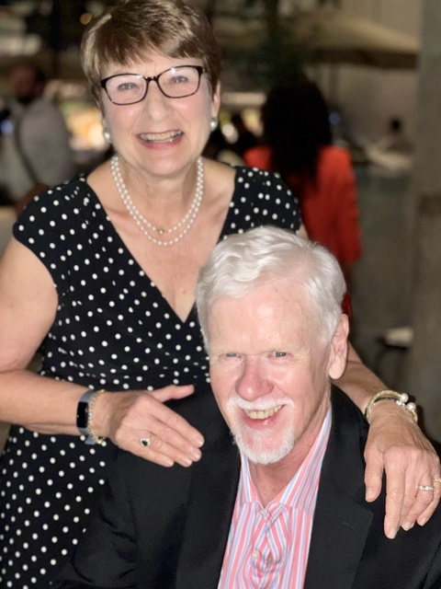
Merry Christmas & A Happy New Year to my former classmates and to other Alumni whom I have had the pleasure of meeting and collaborating with since my departure from the hallowed halls of 555 West End Avenue in 1968.
I refer you all to MY JOURNEY already posted on the web site to articulate how I have progressed over the years. https://www.ssppalumni.com/Cathedral/viva_MurphyJoseph.htm

