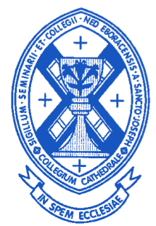

Cathedral College/Cathedral Prep Alumni Assoc.
201 Seminary Ave.
Yonkers, NY 10704

October 7, 2024

Dear Alumni:

The Alumni Association will be holding our annual Christmas Mass and dinner on Thursday, December 5th, 2024. Rev Robert Norris (Prep ’72) has again offered the use of the Church of Our Lady of Mt. Carmel located at 59 East Main Street, Elmsford, NY 10523. Mass will start promptly at 6:00 PM. Dinner will follow at Casaletto Ristorante, 15 S Central Ave, Elmsford, NY 10523 at 7:00 PM. Dinner will include: appetizer, choice of entree, dessert and beer, wine and soda. Despite holding off a price increase for the past two years, the restaurant finally passed on a price increase. The cost of the dinner this year will be $80. The $80 includes a gift to the food pantry run by the Church of Our Lady of Mt. Carmel and a gratuity. Please indicate on the slip below your intention to attend the Mass and dinner and include your check for $80.00.

We have heard from many alumni that they really enjoy reconnecting with their fellow classmates. We encourage alumni, particularly those living in the tri-state area to use our two annual events as a way to get together with their classmates and celebrate Mass as a group with other alumni.

At this time, we are requesting that you please submit your Association dues ($20) for 2025. The Association’s finances are now structured in such a way that the dues are directed almost entirely to the annual scholarship presented to a seminarian studying for the Archdiocese of NY. Rev. Richard Veras, who is in charge of college level seminarians for the Archdiocese of NY, attended our most recent Board meeting. He told the Board that one of the seminarians to whom the Association awarded scholarship money admitted that he might not have been able to continue his studies without our help – so we have proof that our efforts are bearing fruit!

A number of our alumni have responded very generously to our efforts in supporting seminarians. In particular, the Prep class of 1974 who celebrated their 50th anniversary of graduation from the Prep and joined us as part of their celebrations at the Spring Mass/Dinner in May of this year. Because of the generosity of such donors and based on the recommendations of Father Veras, we are presenting a $4,000 scholarship to a college level seminarian who is struggling to pay off previous college debt in order to continue his seminary studies. We will also be awarding a $1,000 scholarship to the same seminarian whom we have helped the prior two years. We provide our support to seminarians whose families are unable to support them financially. We will also be presenting “recognition” awards of $250 each to 4 other college level seminarians who are not in financial need. We want to do this as a show of support for their efforts. Our total support for the seminarians will total $6,000 this year.

For those alumni who cannot attend the dinner, please know that you are still sharing in our mission to support vocations to the priesthood. The scholarship has been named the William Poli/Vincent Scotti Memorial Scholarship in honor of two long serving faculty members of Cathedral College. We are inviting both Mr. Poli and Mr. Scotti as our guests to the Mass and dinner so they can personally make the presentation of the scholarship that now bears their name. We are also hoping to have members of the College Class of 1968 who are celebrating their 50th anniversary of priesthood as our guests!

Cathedral Preparatory School and Seminary in Elmhurst, NY (only 1 of 2 prep seminaries remaining in the U.S.) has been working with our Association to attempt to bring together Alumni groups from the dioceses of New York, Brooklyn and Rockville Center. They have planned a dinner for Friday, October 25, 2024 at the Inn at New Hyde Park starting at 6:30 PM. One of our Board members, Wilson Martinez Prep ‘73, will be one of the honorees at the dinner. We would like to have a show of support for the group’s mission and for our representative. Individual tickets for the event are $200.00 per person. You can register for the event by using this link: www.cathedralprepalumni.com

THE PREP SHIRTS ARE FINALLY AVAILABLE!! We have chosen a polo shirt made by Nike. The polo will be in navy with the Cathedral College insignia and the wording “Cathedral Prep Manhattan” in gold below it. The cost of the shirts will be $62. (If you pay by PayPal, please add $2 for their processing fees.) This amount includes mailing to you. I will order only the quantity and size of shirts that are specifically requested by the alumni. Therefore, we will not be able to accept returns for incorrect sizes – so choose wisely. I have included a size chart below from the manufacturer for reference. Many of you have indicated before that you wanted a shirt and provided your size - I will NOT order based on that since we did not have the final price prior to this. I will ONLY place orders for those people who respond on the form below with the size based on the size chart provided and include payment. We will not be ordering again for the time being – so get your orders in now!

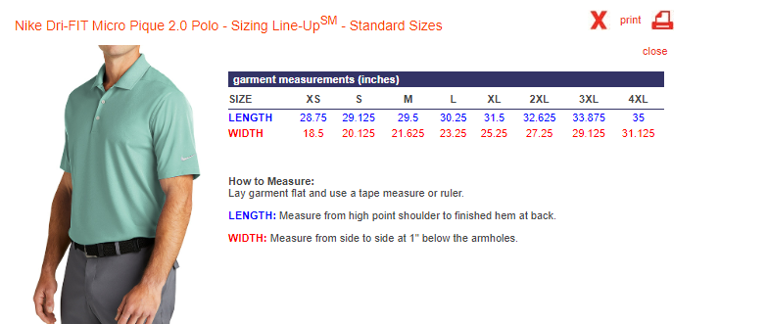

For those people wishing to use Paypal to pay for dues, dinner or shirts, we have set up a PayPal account for the Association. Use cathedralcollege@yahoo.com to send amounts via Paypal. Paypal charges us a 3% processing fee so please add accordingly to defray the cost.

As always, if you have any names, addresses (mail and e-mail) of alumni that you would like to have included on our mailing list – please do so – and we will add their names to our mailing list.

Internet Resources available for Cathedral Prep/Cathedral College Alumni.
On the site administered by Jim Manning http://www.cpcc555.org, Jim and Rick Rosario (Prep ’87) have completed a project to digitize Cathedral Prep yearbooks, as well as issues of the Chimes and Cathedralite. If you wish to be notified of updates to this web site, email Jim Manning at HEGNEY750APT9@AOL.COM.
Alumni directories by class year along with contact information are available at: http://stlukes- parish.org/cathedral. The directories are maintained by Ed Behn, Prep ’68.
Facebook: Cathedral College Cathedral Prep Alumni Association (Manhattan) - link https://www.face book.com/groups/1031291000372044/ The Facebook page is administered by Joe Fusco, Prep ’68, Douglaston ’72.
——————————————————————————————————————————Please return this response form no later than November 15, 2024 to Cathedral College/Prep Alumni Association, c/o Tom Sheridan, 39 Van Cleef Drive, Whitehouse Station, NJ 08889. If you have any questions, Tom Sheridan’s e-mail is taras16428@aol.com.
Name _____________________________________
Year of Graduation: Prep:________College:_________ (indicate Cathedral (C )or Douglaston (D)
Your e-mail address_________________________________________________________
______I/We will attend the Christmas Mass/ Dinner (Please include a check for $80 per person made payable to Cathedral College/Prep Alumni Association).
______I am submitting my dues of $20 for 2025. (Please include a check for $20 made payable to Cathedral College/ Prep Alumni Association. If you are submitting for both dinner and dues, one check is ok.)
_____ I would be interested in purchasing a Cathedral Prep polo shirt. My size is __________. Please include a check for $62 made payable to Cathedral College/Prep Alumni Association.

NB: If you are enclosing payments for multiple items e.g. dues and dinner, you may combine the amount on one check. No need to send multiple checks. Same goes for PayPal.

